PROJECT PROPOSAL: HISTORICAL OLYMPIC PERFORMANCE & PHYSIOLOGICAL BENCHMARKING
Client Engagement: SportsStats Analytics Consultancy
Target Audiences: Elite Athletic Performance Coaches & Regional Sports Media Partners
Primary Analyst: Saurav
Specialization: UC Davis — Learn SQL Basics for Data Science Capstone

1. Executive Summary
SportsStats has been commissioned to conduct an exhaustive relational database investigation into 120 years of modern Olympic history (1896–2016). Operating as a dual-purpose analytical initiative, this project translates historical sports competition logs into high-value intelligence for two distinct client groups:
- Elite Athletic Coaches & High-Performance Academies: Conditioning specialists requiring empirical anthropometric targets (height, weight, body mass index) and career peak performance age brackets to guide talent scouting and athletic development cycles.
- Sports Media & Journalism Outlets: Broadcast and print sports journalists requiring data-backed historical context, verified dominance patterns, long-term participation milestones, and longevity profiles to power human-interest features.
By structuring, cleaning, and querying the Olympic historical dataset in SQL, this engagement replaces anecdotal assessments with quantitative benchmarks and data-driven narratives.

2. Business Context & Problem Statement

2.1 The Elite Athletic Training Problem
High-performance conditioning programs often rely on generalized physical health metrics or contemporary anecdotal evidence when setting developmental benchmarks. Aspiring athletes frequently lack empirical physiological targets calibrated to their specific sporting disciplines.
- Business Need: Coaches require clear statistical distributions of winning biometrics (height, weight, BMI) broken down across diverse sports. Furthermore, training academies need to understand the competitive lifespan of each discipline—specifically the age window in which gold medalists consistently achieve peak performance—to optimize training timelines and athlete development paths.

2.2 The Sports Journalism Problem
Mainstream sports coverage frequently relies on high-level, repeated all-time medal counts without historical depth or context. Broadcasters and editors struggle to identify unique historical angles that resonate with audiences.
- Business Need: Journalists require verified storylines covering long-term national event monopolies, multi-decade athletic dynasties, and demographic transformations—such as the historical evolution of female athletic representation across Summer and Winter competitions.

3. Project Objectives & Analytical Scope
The project executes five core analytical objectives designed to address stakeholder questions:
- Objective 1: Anthropometric Profiling Across Sports (Coaching Focus)
Calculate the average height, weight, and Body Mass Index (BMI) of Olympic medalists across high-volume sporting disciplines to define target physiological archetypes.
- Objective 2: Peak Performance Age Windows & Career Lifespans (Coaching Focus)
Determine the minimum, maximum, and average ages of gold medal winners by sport to identify early-specialization events versus long-career endurance/skill sports.
- Objective 3: True National Event Dominance (Media Focus)
Implement deduplicated event-level medal aggregation—ensuring team rosters do not artificially distort national counts—to rank the most dominant nations per event historically.
- Objective 4: Athletic Longevity & Multi-Games Outliers (Media Focus)
Identify historic outlier competitors who maintained multi-Olympic medal consistency across spans of 12 or more years.
- Objective 5: Longitudinal Evolution of Female Participation (Media Focus)
Measure and analyze the historical shift in male-to-female athlete participation ratios from the inaugural 1896 Games to 2016 across both Summer and Winter editions.

4. Dataset Architecture & Relational Data Model
The analysis is conducted across two primary relational tables provided in the SportsStats repository:

4.1 Table Specifications
- athlete_events (Fact Table): Contains 271,116 competition event records detailing competitor identifiers, demographics, competition categories, and medal outcomes.
- noc_regions (Dimension Table): Contains 230 reference records mapping National Olympic Committee three-letter codes to standardized geographic entities.

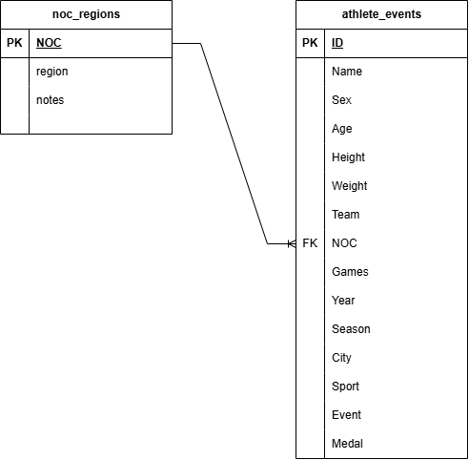

4.2 Relational Integrity
The fact table links to the dimension table through the foreign key relationship athlete_events.NOC = noc_regions.NOC. This link ensures that regional reporting uses standardized sovereign entities rather than variable team or club designations.

5. Data Hygiene, Quality Audit & Methodological Considerations
To maintain analytical accuracy and meet UC Davis capstone standards, the SQL implementation will account for the following data characteristics:
- Handling Missing Biometric Values:
Historical tracking of athlete height and weight was inconsistent in Olympic Games prior to 1960. Queries involving biometric aggregations will explicitly filter out records where Height IS NULL or Weight IS NULL to prevent skewed averages. The final report will document this effective analytical era.
- Correcting for Team Sport Medal Multiplicity:
In team competitions (such as Basketball, Rowing, and Relay events), every roster member receives an individual medal row. Directly running COUNT(Medal) on the fact table artificially inflates medal counts for nations dominating team sports. Country-level rankings will use Common Table Expressions (CTEs) to group by (Year, Season, Sport, Event, Medal, NOC) before aggregating, isolating distinct winning events.
- Orphan Key Resolution:
Certain historical, individual, or refugee designations (e.g., ROT, IOA, historical entities) may not directly match standard sovereign codes in noc_regions. All table joins will use LEFT JOIN combined with COALESCE(noc_regions.region, athlete_events.Team) to ensure no valid athletic achievements are dropped from regional summaries.
- Physiological Feature Engineering:
To provide standard metrics for trainers, Body Mass Index (BMI) will be computed dynamically within the SQL queries using the formula:
$$\text{BMI} = \frac{\text{Weight (kg)}}{(\text{Height (cm)} / 100.0)^2}$$

6. Project Phasing & Implementation Roadmap
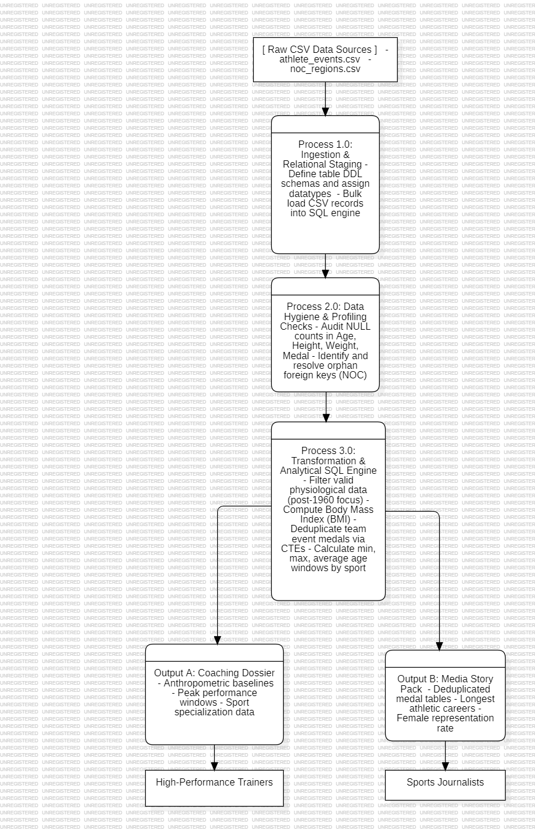

7. Expected Final Deliverables
Upon completion, the project will provide SportsStats stakeholders with:
- Production-Ready SQL Scripts: A clean, commented SQL file containing database initialization, table profiling, and the analytical query suite.
- The High-Performance Coaching Dossier: Structured data tables detailing biometric profiles (ideal height, weight, and BMI ranges) and athletic aging curves for major Olympic sports.
- The Sports Media Story Pack: Verified historical narratives, including event monopolies by country, longitudinal participation growth trends, and deep dives into the longest athletic careers on record.
- Capstone Technical Report: A fully articulated PDF/Word report conforming to all UC Davis evaluation criteria, addressing data limitations, methodology, query outputs, and strategic recommendations.

